**Facilitating the Promotion from Tool to Service in Course Selection Software**

**Applying Socially-Derived Task Queries, Data Visualization and Design Thinking to UCSD CAPE**

Adam Powers

**Introduction:** University students are tasked frequently with the process of determining which courses they should enroll in for a given academic term. There are predictable and largely non-negotiable constraints associated with this particular solution space, which include the specific degree program, elective, and institutional course requirements set out for the area of study, as well as a general filtering introduced by the student’s own perceived capabilities and topic interests. Despite these boundaries, however, the number of available options for any given term can still be quite large and cognitively taxing to navigate, especially at institutions which encourage and facilitate interdisciplinary study.

There has been much written in the behavioral sciences on the phenomenon of choice paralysis, and there is little reason to suspect that it is not a relevant consideration in the course selection process. There is equally little reason to assume that simply because a system contains boundaries, the contents within those boundaries are visible to all users of that system – indeed, given a large number of available electives, there might be several courses which might satisfy a particular student’s educational objectives far better than others, yet elude attention in all but an extensive discovery process. This problem gains an additional dimension when one considers that most courses can be taken during any of several possible terms during an educational career, courses may undergo redesigns and instructor replacements over time, and schedules are often finalized opportunistically and under duress.

Students are aware of these issues, to varying degrees, and frequently employ strategies to further narrow and optimize their solution space. Among the most prominent are peer recommendations, which may take the form of informal polls conducted among groups of personal friends, or the use of tools and systems designed to aggregate opinions on course and instructor quality from a broader cohort. Both approaches have obvious advantages and drawbacks: polling one’s own social network may allow for more personalized, relevant information at the expense of a more representative variety of opinion, and course recommendation aggregators may lack relevancy and normalization – consider Rate My Professor*,* a multi-institution web app where an instructor’s “score” is averaged across the entire array of courses they teach, and evaluable attributes are broadly-defined, like ‘easiness’ and ‘clarity’.

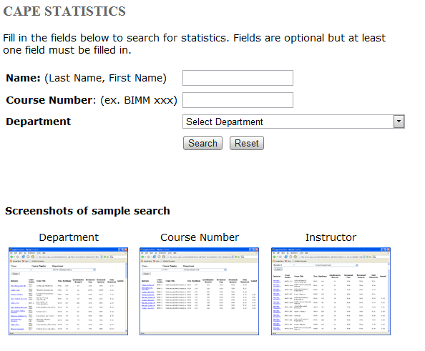**Institution-Specific Background:** The undergraduates at UC San Diego – the only institutional population considered for the purposes of this proposal – have a specialized tool called CAPE, or Course And Professor Evaluations, which are electronic surveys administered for nearly every course offered each quarter, aggregated and presented online (cape.ucsd.edu).

CAPE attempts to fill the desire for granular evaluation with a variety of questions aimed at soliciting feedback about multiple facets of the course and professor experience, and is the only tool that collects such data on a campus-wide scale. The only other similar resource is the AS Grade Distribution Tool (*as.ucsd.edu/gradeDistribution*), which simply lists the distribution of grades in a given course as recorded by the UCSD Registrar, but contains no subjective input from students themselves.

**Possibility and Proposal:** UCSD is an internationally-acclaimed institution, consistently placing competitively in both national and worldwide rankings. And yet it is also a young one, relatively speaking, rife with unexplored opportunities to develop campus resources and find useful synergies between existing ones. CAPE is one such resource, valuable for being solitary in its mission, yet spartan and unintuitive in the presentation and navigation of its data.

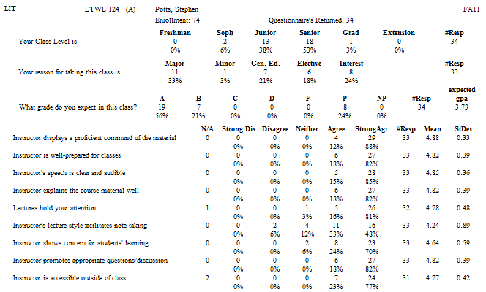Course evaluation results [left] are displayed in a multi-part tabular layout, black-on-white, with no fewer than five columnar arrangements competing for visual attention, and even figures within columns are arranged without regard to readability or ready comprehension.

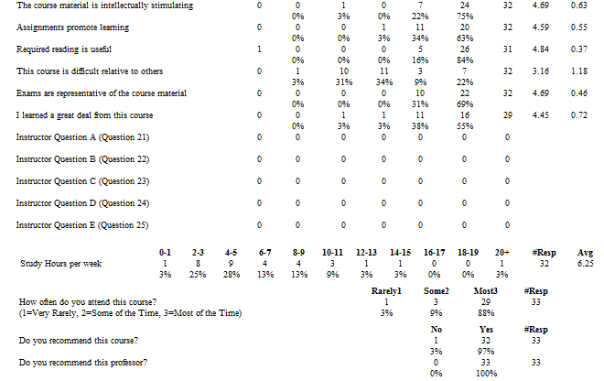The layout assigns equal visual importance to all information (including null questions), makes no effort to facilitate comparisons between related aspects of the data, and the location of each response question appears to be largely arbitrary.

The site navigation [below] is restricted to search boxes and text links to the survey results, with a single drop-down to indicate department. There are no features to compare the same course across multiple years for which there is data, nor to view statistics relating to a professor who has taught multiple courses.

Given the user experience of CAPE as described and the dearth of course-planning resources for UC San Diego undergraduates, there appear to be two opportunities which present themselves in sequence:

*Improve the user experience of CAPE by using good design practices and modern web technologies to facilitate interactive and contextually-focused exploration of survey data*

*Integrate additional resources into the improved CAPE experience to expand its usefulness from a single-purpose tool to a course recommendation and discovery service*

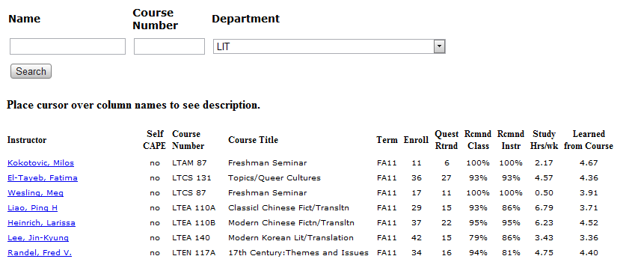**Intellectual Merits:** University course recommendation systems currently exist, but none published appear to have approached the space primarily from a design perspective, or produced a tool designed specifically for ease-of-use. It would be interesting to measure any effects that highly-facilitated access to reliable and socially relevant course and professor evaluation data might have on existing practices of course selection, and how it might affect the courses eventually selected.

CAPE is not only used by undergraduates; professors and department administrators analyze the survey data for the purposes of incorporating student feedback into the refinement of their course designs, and it follows that any improvements in response rate as a result of enhanced usability could do nothing but improve the quality of conclusions drawn from such data as a result.

As far as groundwork and experience goes, I have built a relationship with the CAPE administration department at UC San Diego, obtained permission to acquire multiple years of their database for analysis, and have discussed the possibility of donating work of sufficient quality back to the department to serve as the data’s official frontend. I have years of experience with web development technologies, bolstered by recent courses in aesthetics, design, and project management.

**Broader Impacts:** I would argue that education is one of the most fruitful domains for exploration and the ripest for improvement, owing to its foundational role in the development of intellect and identity and as the infrastructure which supports one’s entire experience of acquiring knowledge. To optimize, create, or enhance of any of the innumerable practices, constructs, or resources of which the enterprise is composed is to potentially make far-reaching and similarly foundational impacts upon all those who participate in the educational process.

One’s career as a student is comprised, at its core, of only a few dozen term-length courses, giving each a degree of weight and importance concerning the skills acquired by graduation. Some will be more influential than others, and indeed particularly influential or enjoyable courses and professors can drastically alter one’s trajectory of study and potentially their eventual degree.

I see CAPE as being well-suited to become the nucleus of a web-based service that integrates data from multiple sources to provide students with statistical, social, and institutional information that maximizes their ability to make educated decisions when selecting classes, enables intuitive exploration of otherwise obtuse and inaccessible evaluation data, and facilitates the discovery of particularly relevant courses that they might not otherwise have become aware of.

**Outline of the Proposal:**

1. I’ll begin by describing in greater detail the information provided by the current CAPE implementation, and other sources of information that might be integrated along with it.
2. I’ll discuss some ways in which the various sources of information might be combined to increase their overall value.
3. I’ll follow by proposing ideas to display the complete set of information in a way that facilitates discovery, increases quality of the data, and promotes its status from a tool to a service.
4. I’ll briefly discuss options for implementing these changes, and conclude the proposal.

1. Available Points of Data in the Existing Ecology of Resources

This section is an overview of the materials readily – or conceivably – at one’s disposal when determining the potential ways to add value during a CAPE redesign.

**CAPE:** Below is a table which reflects the information captured during a CAPE evaluation, and the options respondents have for answering each question. Note also that for most classes that have been offered for that long, CAPE data is available as far back as 2007.

|  |  |  |
| --- | --- | --- |
| **Area of Focus** | **Question or Statement** | **Available Options** |
|  |  |  |
| Demographic | Class level | Freshman, Sophomore, Junior, Senior, Grad, Extension |
| Demographic | Reasons for taking the course | Major, Minor, Gen. Ed., Elective, Interest |
| Demographic | Expected grade in course | A, B, C, D, F, P, NP |
|  |  |  |
| Instructor | Displays command of material | 5-point Likert (Strong Disagree-Strong Agree) + N/A |
| Instructor | Prepared for class | 5-point Likert (Strong Disagree-Strong Agree) + N/A |
| Instructor | Speech is audible and clear | 5-point Likert (Strong Disagree-Strong Agree) + N/A |
| Instructor | Explains course material well | 5-point Likert (Strong Disagree-Strong Agree) + N/A |
| Instructor | Shows concern for students’ learning | 5-point Likert (Strong Disagree-Strong Agree) + N/A |
| Instructor | Promotes appropriate discussions | 5-point Likert (Strong Disagree-Strong Agree) + N/A |
| Instructor | Is accessible outside of class | 5-point Likert (Strong Disagree-Strong Agree) + N/A |
| Instructor | Starts and finishes class on time | 5-point Likert (Strong Disagree-Strong Agree) + N/A |
|  |  |  |
| Lecture | Facilitates notetaking | 5-point Likert (Strong Disagree-Strong Agree) + N/A |
| Lecture | Holds attention | 5-point Likert (Strong Disagree-Strong Agree) + N/A |
|  |  |  |
| Course | Material is intellectually stimulating | 5-point Likert (Strong Disagree-Strong Agree) + N/A |
| Course | Difficulty relative to other courses | 5-point Likert (Strong Disagree-Strong Agree) + N/A |
|  |  |  |
| Assignments | Assignments promote learning | 5-point Likert (Strong Disagree-Strong Agree) + N/A |
| Assignments | Exams representative of course material | 5-point Likert (Strong Disagree-Strong Agree) + N/A |
| Assignments | Required reading is useful | 5-point Likert (Strong Disagree-Strong Agree) + N/A |
|  |  |  |
| Student (Subjective) | I learned a great deal from this course | 5-point Likert (Strong Disagree-Strong Agree) + N/A |
| Student (Subjective) | Do you recommend this course? | Yes, No |
| Student (Subjective) | Do you recommend this professor? | Yes, No |
|  |  |  |
| Student (Objective) | Frequency of course attendance | Rarely, Sometimes, Most of the Time |
| Student (Objective) | Hours studied per week | 0-1, 2-3, 4-5, 6-7, 8-9, 10-11, 12-13, 14-15, 16-17, 18-19, 20+ |

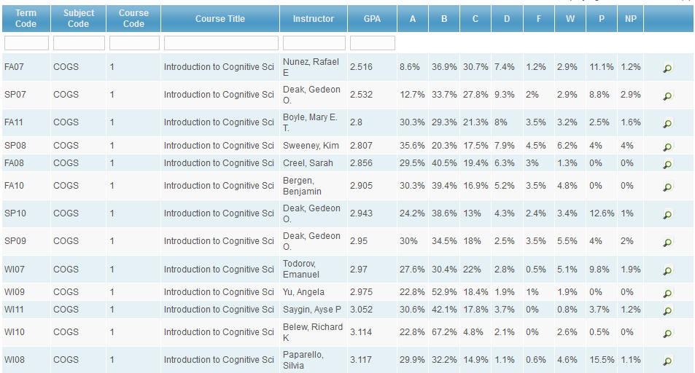  
**Grade Distribution Tool:** For any given undergraduate course, the Grade Distribution Tool hosted by the ASUCSD [right] displays the percentage of A-F, P, NP grades assigned to the enrolled population for that term, as well as the resulting GPA of all the grades assigned.

**Social Networks:** A significant proportion of UCSD undergraduates utilize social networking sites such as Facebook for connecting with classmates, publicizing organizations, and building community. Facebook’s extensive OpenGraph API allows for integration with practically any application, enabling that application to suggest activities to the user based upon information in their profile as well as the activities of those in their contact list. It would not be outside the realm of possibility to author, as part of the project, a Facebook application that allows users to specify their registered courses for the quarter and expose it to CAPE as an available resource.

**Peer Recommendations:** As mentioned, one of the most potent resources used to determine course selection. This is the driving force behind Rate My Professor’s popularity, as even students who ignore the numerical ratings often find value in the comment threads attached to particular classes. Note that the concept of “peer” may vary between students, some of whom may prefer information only from those whose educational objectives match their own, or who belong to their specific program or specialization. If given, the opportunity should be taken to favor a student’s personal acquaintances and closest scholastic peers over the opinions of strangers.

**Course Catalog:** UCSD maintains brief paragraph-length descriptions of all courses offered. It highlights the relevant material covered, the skills gained through enrollment, and any preexisting knowledge assumed, as well as necessary pre- and co-requisite coursework.

2. Assessing Opportunities to Add Value through Combination and Comparison

**Useful Comparisons:** This section primarily concerns itself with exploring how, by merely facilitating comparisons between currently available data, additional value might be perceived by an undergraduate making their course selection choices, and discusses how the metric of “quality” is in some ways subjective, and might be constructed differently between individuals.

**Analysis of Likert Data:** Most of the CAPE responses are on 5-point Likert scales which span from “Strongly Disagree” to “Strongly Agree”, with “Neither” as a midpoint. It’s worth mentioning that I’m aware there are challenges in converting such data to a format that lends itself to statistical analysis, and an earnest undertaking of this project would involve finding a suitable solution to the matter. CAPE provides the mean and standard deviation for all of their Likert data, which will assist greatly in some cases.

**Addressing “Quality”:** Most of the comparisons that can be made ultimately attempt to answer, in their own way, the same question: What is the quality of this course, professor, or course/professor combination? CAPE provides several metrics for evaluating course and professor quality that could be combined into larger, more encompassing measures, but are not. CAPE’s single overarching measure of quality – “do you recommend this [course/professor]?” – gets to the point, but reasons why an individual respondent might provide either answer could vary widely, and might not be aligned with the values of the student using it to make a decision.

**Building Quality Measures:** If other data is brought in to control for this potential variation, more reliable measures might be derived that can be used in all other comparisons that rely upon quality as a variable; and if these measures selectively emphasize specific constituents in alignment with the needs of the most relevant user personas, “quality” can become a fairly personalized term that accurately reflects the student’s own priorities. The next two topics are simple examples of such tuning.

**All Relevant Measures, Across Time:** By combining the scores of all response questions that pertain to a particular aspect of evaluation – such as all “Instructor” questions in the CAPE table shown previously, along with the “do you recommend this professor?” question – and sum them across time, a cumulative score might be derived that serves as a more reliable indicator of professor quality.

**Tuning Professor Quality for Competence and Legibility:** Combining the data from CAPE questions relating to command of material, preparation for class, clarity of speech, and explanation of course material, while excluding considerations such as finishing class on time, regular office hours, and specific concern for learning outcomes – which might be more broadly grouped under “Empathy and Accessibility” and used as another set of parameters – gives a measure of quality which, while certainly biased, might reflect realistic differences in priorities students consider when evaluating professors.

**Quality for the Purposes of the Proposal:** I will utilize the general recommendation response as the default measure of quality for the purposes of the examples hypothesized below, with the understanding that it may be substituted with more personalized variants when under actual development.

**List of Hypothesized Comparisons:** The rest of this section will follow the format of a proposed data comparison, the variables used in its construction, and whether the measure involves the responses from only a single course, across all courses taught by a particular professor, or across all courses with that title, regardless of instructor. This is by no means an exhaustive list of possibilities, as requirements gathering research and the formation of data-driven personas would likely add many additional considerations.

**Professor Quality Trending |** CAPE (Professor Recommended %), Time | Across courses taught  
To determine how a professor’s quality varies over time. As many high-enrollment courses (e.g., the MATH 10 series) have multiple offerings taught by different professors, this measure allows the student to select the consistently highest-quality professor available, or avoid professors whose ratings have been declining over time. (Care would have to be taken to ensure this did not create runaway effects due to innocent spikes in data.)

**Course Quality Trending** | CAPE (Course Recommended %), Time | All courses with title  
For required courses that don’t serve as a foundation for other coursework, such as General Education requirements or electives, students may use this measure to determine if a class may be taken at another time – if the quality rating is trending upwards or staying stable – or taken immediately, if quality is trending downwards but an instructor change or course redesign is unlikely.

**Grading Transparency** | CAPE (Expected Grade), Grade Distribution | Specific course  
CAPE solicits feedback from the respondent on the grade they expect to receive in the class. The distribution generated by this question may be compared with the actual distribution from the Registrar, and a significant delta might indicate a lack of transparency or legibility in how assignment and exam grading policies are communicated.

**“Good Hard” vs. “Bad Hard”** | CAPE (All enjoyment, difficulty, quality measures) | Specific course  
By combining respondents’ assessments of how difficult they found the course with how much they found it enjoyable and stimulating, a measure can be derived of whether a course is challenging because of factors intrinsic to the material, and overcome by a high course quality, or challenging due to external factors such as poor communication, instruction, or organization. This strikes at the root of my displeasure with “Easiness” rankings on sites such as Rate My Professor, as it can be difficult to ascertain whether such assessments are made with respect to the material, the professor, or the student’s own motivation and capabilities.

**Educational Efficiency** | CAPE (Hours Studied Weekly, Learned from Course) | Specific course  
A simple comparison of time spent outside class with amount gleaned from the material could serve as an indicator of how much “learning per hour” a course is likely to provide.

**Ubiquitous Comments** | User-Provided Data | All courses and professors  
While not a comparison per se, it’s clear from the success of other evaluation sites and the nature by which students solicit recommendations from peers that text-based, fully-qualitative comments would be utilized extensively if provided, and would lend a personal scope to every evaluation page. Technological considerations would include balancing anonymity with approved access, which in turn rely on the ability to verify that a given respondent has actually enrolled in the course. Additional research would be required to determine how to proceed.

**“Hidden Gem” Detector** | CAPE (Enrollment Reason), Facebook Data | Specific course  
If a significant proportion of students enroll in a course that does not fulfill major or minor requirements for them (i.e., select “Interest” or “Elective” as enrollment reasons), that course should be highlighted to students in that major as a potentially worthwhile or enjoyable experience that might also fulfill their degree requirements. A limitation of this feature would be its inability to recommend courses based on broader trends, as CAPE does not currently maintain records that allow for tracking students across evaluations; therefore, any additional refinement of this concept (which could very well be the “killer app” for a service of the type being proposed) would have to come from voluntary data contributed by a large group, which suggests integration with a social network. If successfully implemented, students could conceivably receive recommendations for courses that are outside their major, yet would add value to their personalized educational experience, and potentially even count as electives if properly petitioned.

3. Design Ideas for User Experience and Visual Presentation of Evaluation Data

**Significant Changes:** This section contains low-fidelity mockups that attempt to roughly outline the direction I see a redesign of CAPE taking, along with basic examples of some of the data comparisons mentioned in the previous section. The most significant change is to a dashboard-style layout, with tuning options in a sidebar, and interactive data widgets that offer additional options or toggle to alternate functionality.

**Visualizing Likert Data:** CAPE’s presentation of the responses scored on a 5-point Likert scale – which is, to say, the majority of them – does not make specific effort to visually aid comparisons between questions, or over time. One solution to this problem is the conversion from tabbed data to net stacked distribution graphs, which discard non-polar data (the “neither” and “N/A” responses), align graphs along a central axis (the 0 point), and in the example shown below, distinguish between responses using color gradients.

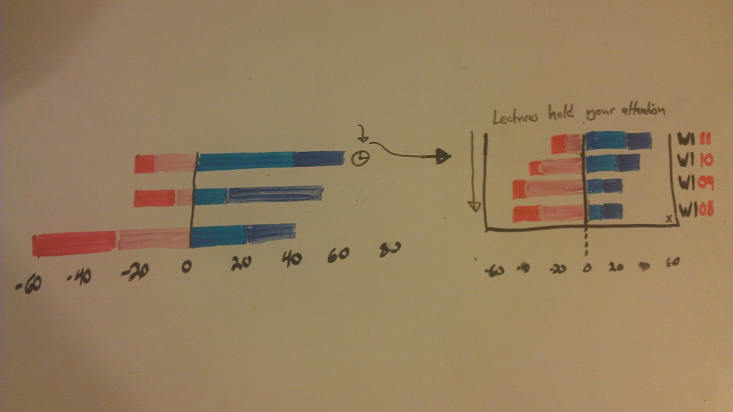

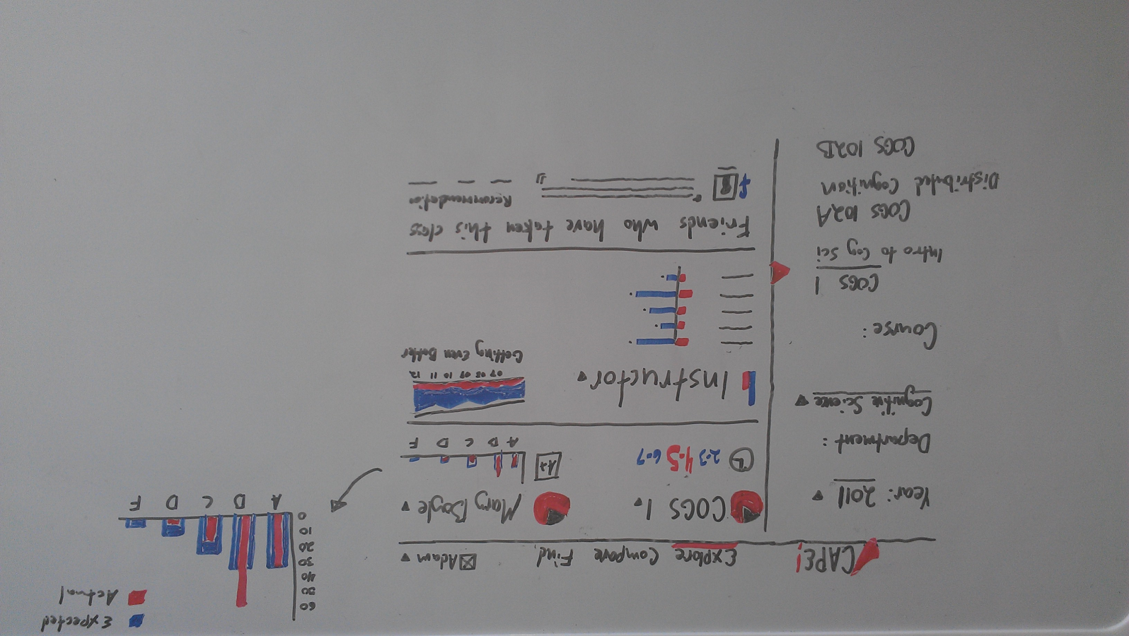To the right of the top graph is a UI element which, when clicked, would instantiate a pull-down shade showing the associated response on top, and its change over previous years of the survey. This facilitates the rapid judgment of whether a particular aspect of evaluation is trending towards improvement or decline.

**Example Dashboard: Default “Explore” View:** Above is a rough mockup of one possible layout for a revised CAPE frontend, with a class already selected.

**Quick Statistics:** The top of the content column attempts to contain the most relevant data about the course, in a format that facilitates quick assessment.

**Name and Instructor:** The iconized pie charts to the left of the course and professor name display the responses from the “would you recommend” question – though this can change to reflect a different quality measure – and when clicked, offer other courses from the same instructor, or other instructors who have taught the same course (respectively).

**Hours Studied:** Below the course and instructor names is the response to hours studied outside class, with the mode value distinguished in color and size, and the next-most-popular responses beside it for comparison. These three values should give a quick and accurate picture of the average time commitment for a class.

**Grade Distribution:** This histogram (shown with blowout view in higher detail) combines data from CAPE and the Registrar, with responses from the former set in wide, dark columns, and the actual distribution data laid over it in thinner, brighter columns. This invites easy comparison between what the course population expected and received, as the eye is drawn both to bright lines in isolation (received > expected) and patches of uninterrupted color (expected > received).

**Instructor Quality:** To the left of the “Instructor” heading is an iconized bar chart showing the summed values of the Likert data below it, which pertain specifically to responses concerning the instructor, and offers a quick summary for those values as well an alternative measurement of overall quality. To the right of it is a prototype of a quality-over-time visualization, with responses grouped by year, a trend line, and a textual summary of the intended interpretation.

**Social Comments:** The bottom of the content column shows a possible view of course-specific comments, with the student’s social network contacts given preferential placement. The suggested phase of this project where social networks are leveraged for additional refinement of peer responses would have to be completed before this feature could exist as described.

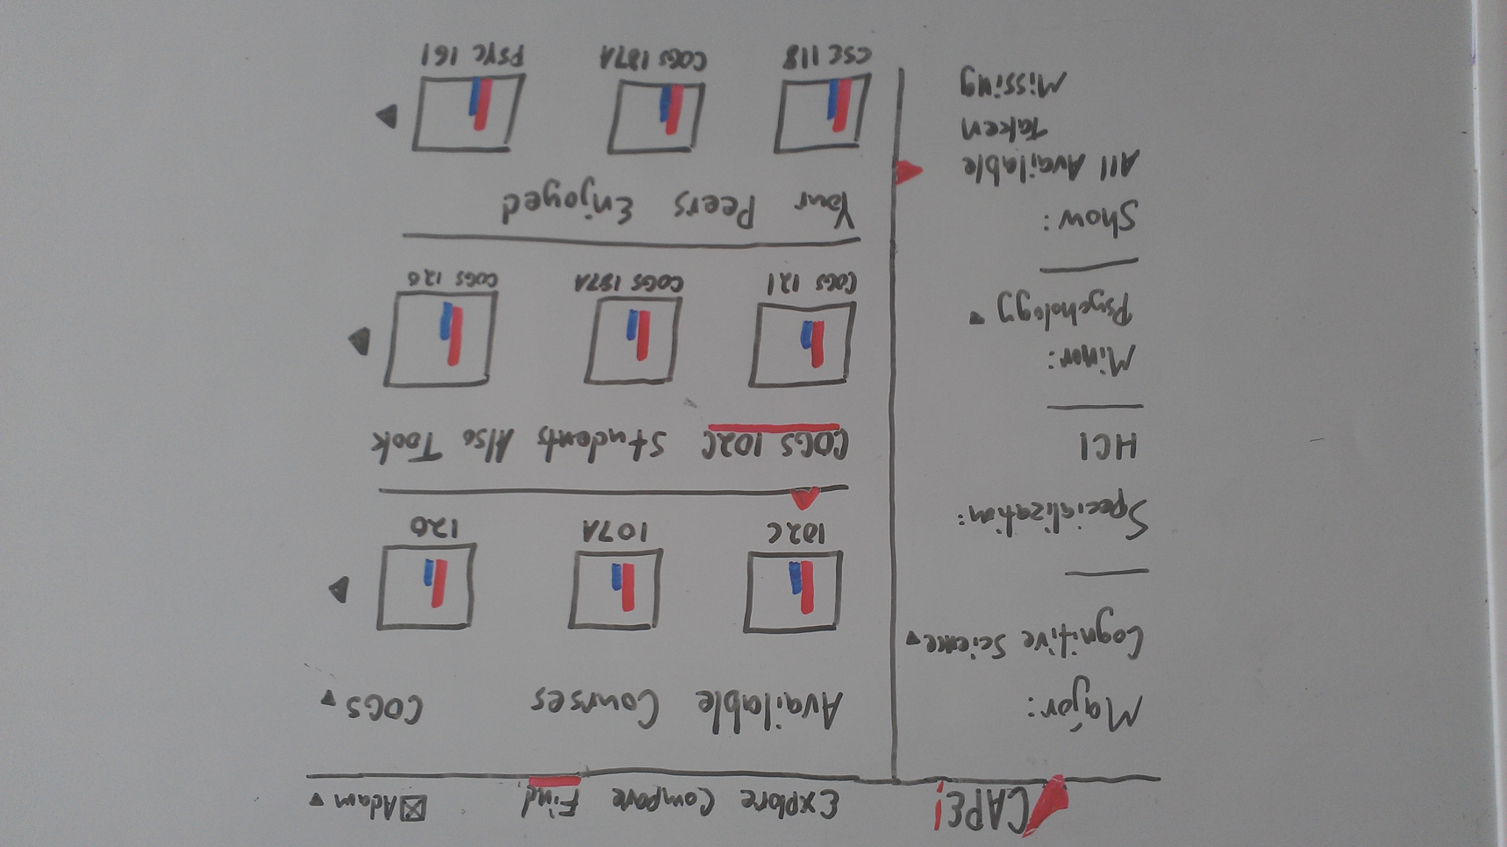**Course Discovery:** This dashboard [left] suggests potential course discovery functionality based on PID matching across CAPE evaluations and perhaps integration with UCSD’s course enrollment data.

In all cases, the iconized visualization shown is an arbitrary placeholder; it’s not yet clear what the single most important factor to display in that space would be.

The top pane of the content column simply lists, in this example, the courses explicitly permitted under major, minor, and elective requirements. Selecting one of the courses populates the second pane with additional options taken by students who had completed that course.

The third pane is more experimental, and would require careful design to achieve its full potential, but the end goal is a list of courses taken by those with similar declared majors, patterns of course enrollment, and enjoyment ratings for those courses. These may not necessarily be within the list of approved electives for that degree, depending on how the particular department’s approach to extra-major petitioning can be accurately captured and used for filtering.

4. Technologies Used for Project Implementation, and Looking Ahead

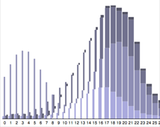**Dynamic Elements:** Being a web-based project, it makes the most sense to use d3 ([*http://mbostock.github.com/d3*](http://mbostock.github.com/d3)) for the implementation of data visualizations, as it’s a popular, well-documented JavaScript library which leverages existing web development knowledge, runs natively in a browser, and was created expressly for facilitating the creation of data visualizations [right] while adhering to standards-based design.

**Database:** Rather than export CAPE’s existing dataset to an external file, manipulate the data into a usable form, and import into an SQL database, the preferred course of action would be to gain access to CAPE’s existing SQL database and use the existing table structure for the construction of a new application. Should the proposed project enter development, an arrangement would have to be made with the CAPE administration department to acquire access – even read-only – to the existing dataset in its currently stored form.

**Backend:** I have existing experience in PHP, and depending on the project’s development schedule, would prefer to build upon it (using an MVC framework like Yii or CakePHP) rather than move to another language. Ruby on Rails and Python would be attractive options to become more familiar with if given the opportunity, but otherwise priority would stay with expedient development.

**Conclusion:** While the ideas presented in this proposal are greatly in need of further refinement, additional supporting research and a distinct methodology for evaluation, I hope I’ve managed to convincingly make the following arguments: the current CAPE implementation is not sufficiently well-designed for the evaluations it presumably was intended to support; even minor design refinements would go a long way towards improving CAPE’s status as a course selection tool; the appropriate use of data visualization and adding value through social network integration could promote CAPE from a tool to a full-blown and invaluable service for the undergraduate community; and the essential elements of the project are capable of being implemented by a reasonable team, within a reasonable scope.

References

[1] “CAPE Statistics.” [Online]. Available: http://www.cape.ucsd.edu. [Accessed: 2012].

[2] “AS Grade Distribution Tool.” [Online]. Available: as.ucsd.edu/gradeDistribution. [Accessed: 2011].

[3] “d3.js: Data-Driven Documents.” [Online]. Available: http://mbostock.github.com/d3/. [Accessed: 2011].

[4] OrganizationView, “Net stacked distribution – a better way to visualize Likert data.” [Online]. Available: http://www.organizationview.com/net-stacked-distribution-a-better-way-to-visualize-likert-data. [Accessed: 2011].

[5] “A Periodic Table of Visualization Methods.” [Online]. Available: http://www.visual-literacy.org/periodic_table/periodic_table.html. [Accessed: 2012].

[6] B. Shneiderman, “The eyes have it: a task by data type taxonomy for information visualizations,” in *Proceedings 1996 IEEE Symposium on Visual Languages*, pp. 336-343.

[7] N. Aloia, M. Matera, and F. Paternò, “Using Tasks for Improving the Presentations for Database Query Results,” in *Proceedings of the 1997 IEEE Symposium on Visual Languages (VL  ’97)*, 1997, p. 121--.

[8] W. Willett, J. Heer, and M. Agrawala, “Scented widgets: improving navigation cues with embedded visualizations.,” *IEEE transactions on visualization and computer graphics*, vol. 13, no. 6, pp. 1129-36, 2007.

[9] B. Liu, “Direct Manipulation Querying of Database Systems,” 2011.

[10] H. F. Unelsrød, “Design and Evaluation of a Recommender System for Course Selection,” *Science And Technology*, no. June, 2011.

[11] K. Stefanidis and M. Drosou, “’You May Also Like’ Results in Relational Databases,” *Science*, 2009.

[12] J. J. Donaldson, M. Conover, B. Markines, H. Roinestad, and F. Menczer, “Visualizing social links in exploratory search,” in *Proceedings of the nineteenth ACM conference on Hypertext and hypermedia - HT  ’08*, 2008, p. 213.

[13] M. Wattenberg and J. Kriss, “Designing for social data analysis,” *IEEE transactions on visualization and computer graphics*, vol. 12, no. 4, pp. 549-57.

[14] B. Shneiderman, “Dynamic Queries for Visual Information Seeking,” *Health (San Francisco)*, pp. 1-18, 1994.

[15] R. Farzan and P. Brusilovsky, “Social Navigation Support in a Course Recommendation System,” *Information Sciences*, 2006.